Functions with ORM stack

Contents

1. Introduction 3
2. Workflow diagram to deploy the stack 3
3. Create stack for Functions 4
4. Plan the Job 6
5. Apply the Job 7
6. Verify in the Console 8
7. Destroy the stack 9

Introduction

Oracle Cloud Infrastructure (OCI) Functions is a serverless compute service that lets developers create, run, and scale applications without managing any infrastructure. Functions have native integrations with other Oracle Cloud Infrastructure services and SaaS applications. Because Functions is based on the open source Fn Project, developers can create applications that can be easily ported to other cloud and on-premises environments. Code based on Functions typically runs for short durations, stateless and run for a single purpose of logic. Customers pay only for the resources they use.

Workflow diagram to deploy the stack

Below diagram shows how the Terraform Artifact are applied in the OCI. While creating a ORM stack, using terraform deliverables Init, Plan and Apply is the flow to provision the resource in the OCI. We can have the deliverables in any of below.

- GitLab/GitHub Repo
- Bitbucket
- Can be in folder/.zip in the local disk
- Object Storage Bucket
- Can be in compartment
- Oracle provided Template


Create stack for Functions

Go to OCI Console Developer Services Resource Manager Stacks select the compartment Create Stack

My Configuration Folder Browse Select the “functions” folder that contains the terraform Upload

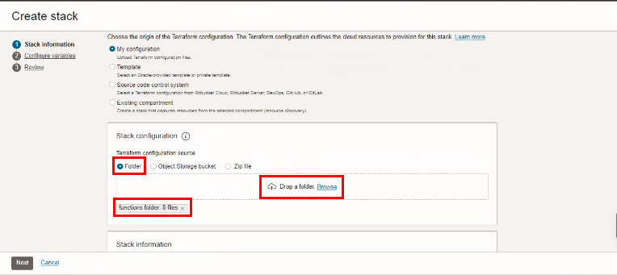

Select the parameters as per the below screen,
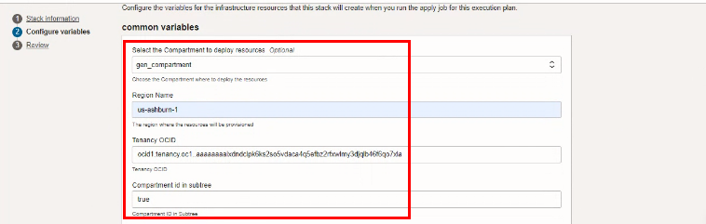

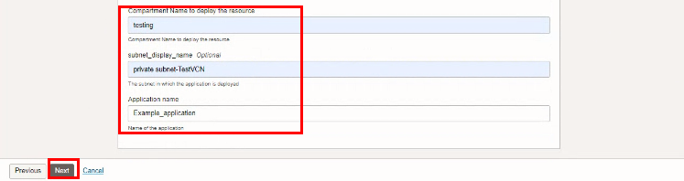
Click “NEXT”
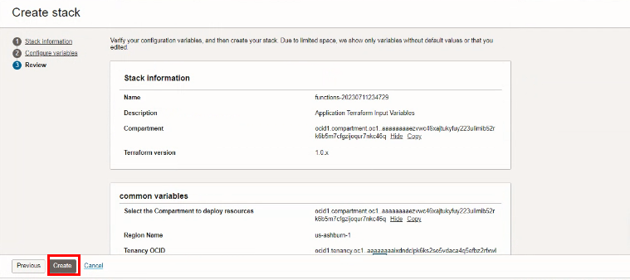
Click “CREATE”

Plan the Job
Click the “Plan”
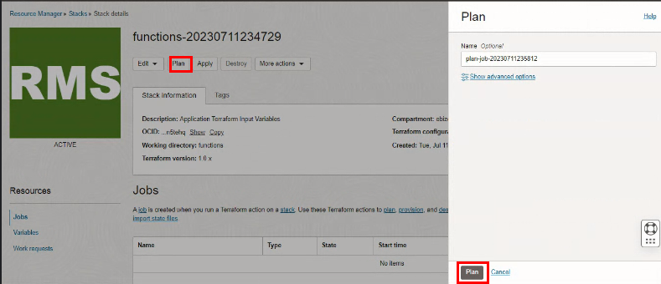

Verify the Plan is successful.
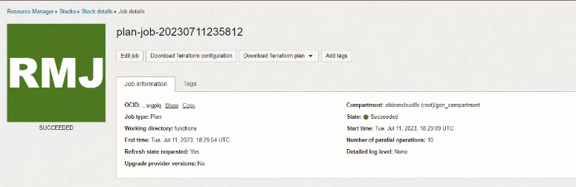
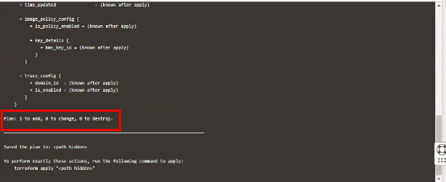

- Apply the Job

Once the “plan” is success, now click “Apply”
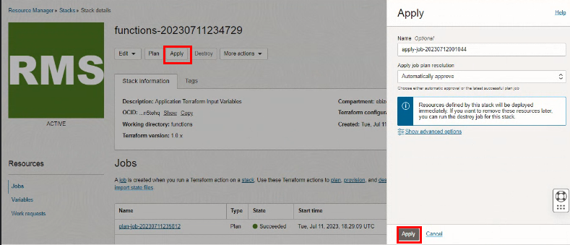

Verify the Apply is successful.
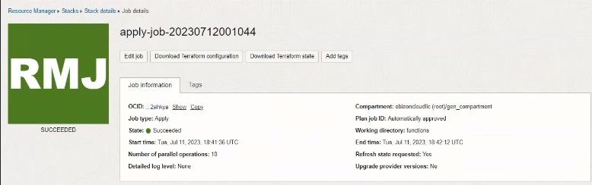
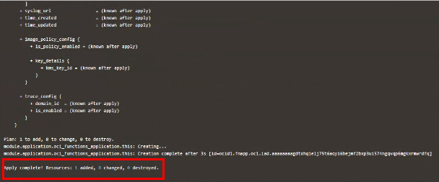

Verify in the Console

Go to OCI Console Developer Service Functions Applications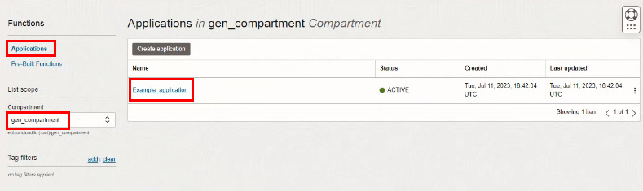

Go to OCI Console Developer Service Functions ApplicationsExample_application

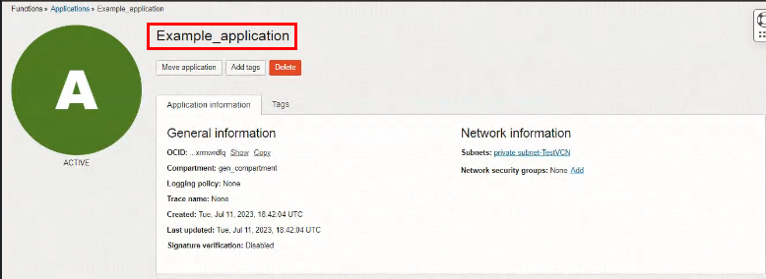

Destroy the stack

Create a destroy job in Resource Manager to release resources associated with a stack and clean up the tenancy. Once destroyed data cannot be recovered from resources.

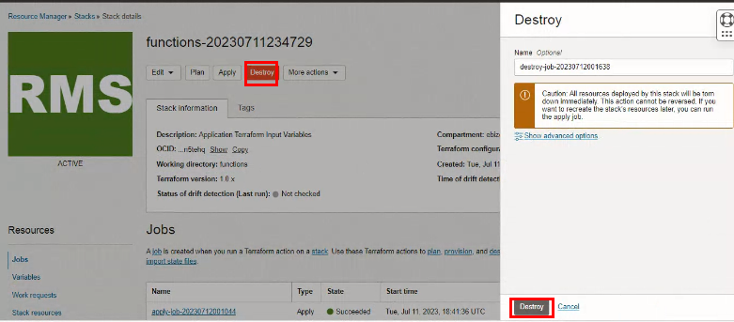

#END#

